Successful GitOps CICD workflow deployment using Helm and ArgoCD
CICD pipeline:
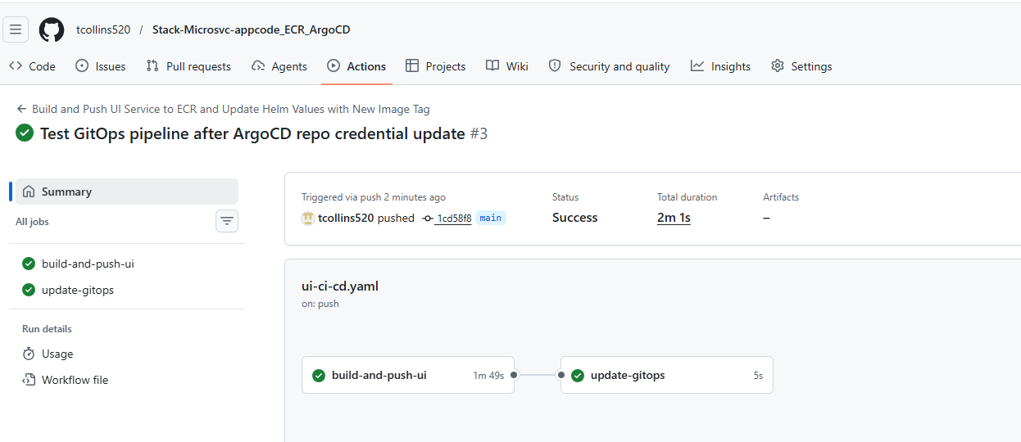
Latest image pushed to ECR:
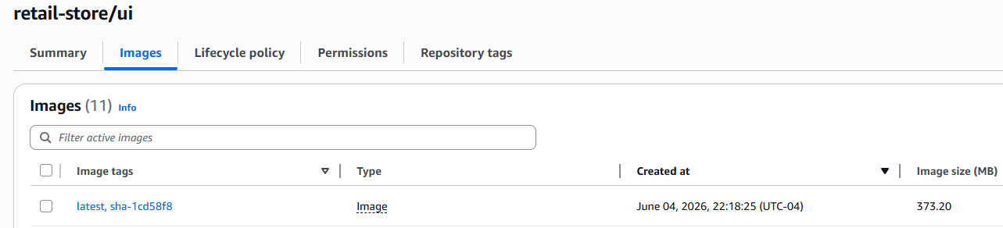
Image tag is updated in GitOps repo to be fetched and deployed by ArgoCD:
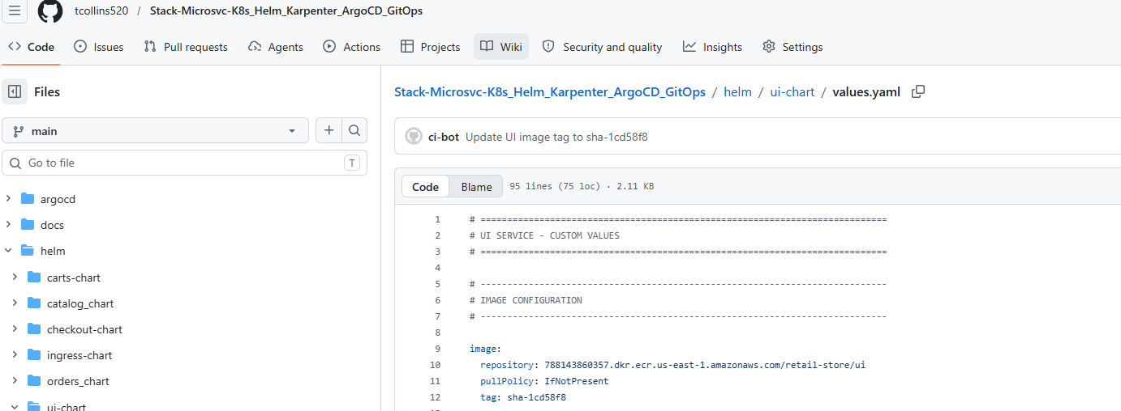

ArgoCD deploys latest ui image tagged from GitOps repo to EKS:
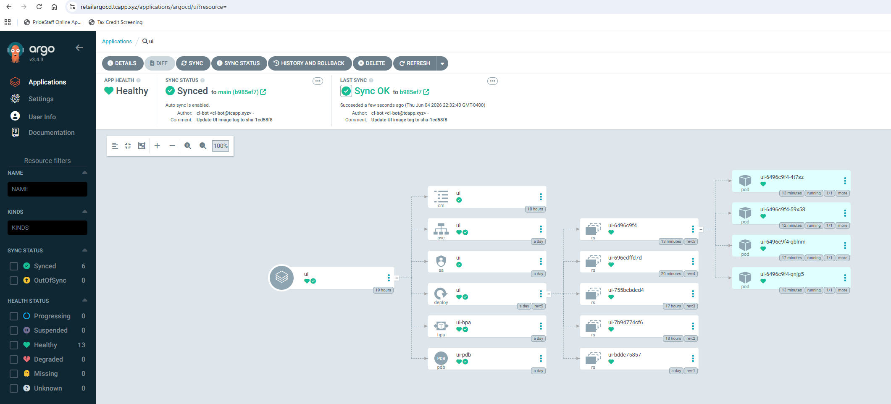
Verified ui app is running latest image:
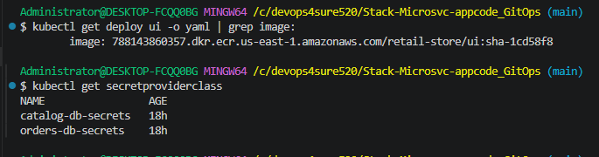
Retail-store K8’s platform
